# Assignment 3

# Part 1

**The Role and Importance of Memory Hierarchy Design in High-Performance Computing Systems**

The design of memory hierarchy is fundamental to contemporary computing architectures, affecting the efficiency and performance of systems from desktop computers to extensive data centers. It involves the strategic arrangement of memory technology and the use of innovative methods to guarantee rapid, efficient, and economical data access. This discourse examines the essential elements of memory hierarchy design, including memory technologies, cache optimizations, virtual memory, and the pervasive issues influencing the advancement of this field.

**Memory Technologies: Layers of Performance and Capacity**

The memory hierarchy in computer systems is organized to optimize speed, capacity, and cost, with various technologies positioned in distinct tiers according to their attributes. Registers and Static Random Access Memory (SRAM) provide the quickest access times; nevertheless, they are constrained by elevated costs and restricted capacity. SRAM is often used in caches where fast data access is essential for CPU efficiency. Level 1 (L1) and Level 2 (L2) caches directly connect with the CPU to retain frequently requested data and instructions. Dynamic Random Access Memory (DRAM), often used as primary memory, offers a balance between speed and expense. Although slower than SRAM, DRAM is much more economical and has enhanced capacity. Nonetheless, it needs regular refresh cycles to retain data integrity, resulting in latency and energy consumption issues. Innovative technologies such as Non-Volatile Memory (NVM) and 3D-stacked memory are transforming the memory paradigm. Non-volatile memory (NVM), including Resistive RAM (ReRAM) and Magnetoresistive RAM (MRAM), provides durability and energy efficiency, making it suitable for storage-class memory. High Bandwidth Memory (HBM) and Hybrid Memory Cube (HMC) similarly position memory in proximity to CPUs, therefore diminishing latency and enhancing bandwidth. These advances enhance conventional technology, creating hybrid systems that maximize performance across various workloads.

**Advanced Cache Optimization: Reducing Latency and Maximizing Throughput**

Caches are essential components of the memory hierarchy, functioning as rapid buffers between the CPU and slower memory tiers. Contemporary computer systems use advanced cache optimization strategies to decrease cache misses, lower latency, and improve throughput. Prefetching is a very effective approach that entails the anticipation and acquisition of data prior to its request by the processor. By using memory access patterns, prefetching may alleviate the latency resulting from cache misses. Inaccurate forecasts might result in superfluous memory traffic, highlighting the need for exact algorithms. Victim caches handle conflicts that arise when numerous data blocks vie for the same cache line. Victim caches temporarily store evicted blocks, allowing for the reuse of recently displaced data, which enhances cache hit rates without necessitating significant structural modifications to the main cache.

Cache partitioning is especially pertinent in multi-core systems, because several processes utilize a shared cache. This approach allocates dedicated cache segments to each process or thread, therefore preventing resource congestion and ensuring consistent performance. This is particularly crucial in settings with diverse workloads, where some programs may need more memory resources than others. Additional methods, like write-back caching, selective invalidation, and replacement rules such as Least Recently Used (LRU), further enhance cache performance, underscoring the intricacy and significance of this layer within the memory hierarchy.

**Virtual Memory and Virtual Machines: Bridging Abstraction and Efficiency**

Virtual memory creates an abstraction that separates a process's memory requirements from the actual memory present in the system. Virtual memory facilitates effective resource management and simplifies the programming paradigm by partitioning memory into pages and maintaining a mapping via page tables. The Memory Management Unit (MMU) enables address translation by turning virtual addresses into physical addresses. To enhance efficiency, Translation Lookaside Buffers (TLBs) store previously used address mappings, therefore reducing the cost linked to frequent translations. Nonetheless, TLB misses may still cause delays, highlighting the need of well built page table layouts.

Page replacement algorithms, including Least Recently Used (LRU) and First-In-First-Out (FIFO), ascertain which pages to remove when physical memory reaches capacity. Efficient techniques reduce the performance impact of page faults, facilitating smooth process execution in memory-constrained contexts. Virtual memory supports virtualization technologies, facilitating the creation of virtual machines that run various operating systems on a single physical platform. This method improves resource efficiency and segregation, essential for cloud computing and corporate settings. Nested page tables and hardware-assisted virtualization techniques mitigate the complexity caused by virtual machines, preserving the integrity of memory hierarchy performance.

**Cross-Cutting Issues: Balancing Trade-Offs and Emerging Trends**

Creating an efficient memory hierarchy requires navigating many trade-offs and accommodating evolving trends and technology. Expenditure and energy use are enduring issues. Costly high-performance memory technologies such as SRAM and HBM are appropriate just for the highest echelons of the hierarchy. Simultaneously, DRAM and NVM provide cost-effective alternatives for primary memory and storage, but with compromises in latency and durability. Energy efficiency is essential, especially in mobile devices and extensive data centers, where power usage directly affects battery life and operating expenses.

The intricacy of hardware and software integration is a further hurdle. Methods such as cache partitioning, prefetching, and multi-level TLBs provide complexity to the architecture, necessitating meticulous validation to guarantee stability. This complexity is exacerbated in systems with heterogeneous architectures, including GPUs, TPUs, and FPGAs, each with distinct memory needs. The variety of workloads also affects the design of memory hierarchies. For example, real-time systems emphasize consistent latency, but data analytics tasks need elevated throughput. Comprehending workload factors is crucial for customizing memory structures to particular applications.

Innovative technology and trends persist in influencing the future of memory hierarchies. Hybrid memory systems that integrate DRAM and NVM are becoming common, providing an equilibrium of velocity, capacity, and durability. Progress in connectivity technologies, including silicon photonics and chiplet topologies, is expected to enhance memory bandwidth and decrease latency. The emergence of in-memory computing and processing-in-memory (PIM) paradigms is fostering innovation by facilitating computation directly inside memory, hence minimizing data transport and related latencies.

The design of memory hierarchy is a crucial element of high-performance computing systems, facilitating the management of the intricate balance of speed, capacity, cost, and power. Designers develop systems that match the requirements of contemporary applications by using various memory technologies, executing sophisticated cache optimization techniques, and employing virtual memory capabilities. Nonetheless, the obstacles of expense, energy efficiency, intricacy, and job variability underscore the need for ongoing innovation in this field. Emerging technologies like as NVM, 3D-stacked memory, and silicon photonics will continue to make memory hierarchies essential for computing performance and efficiency in the foreseeable future.

# Part 2

Cache Performance

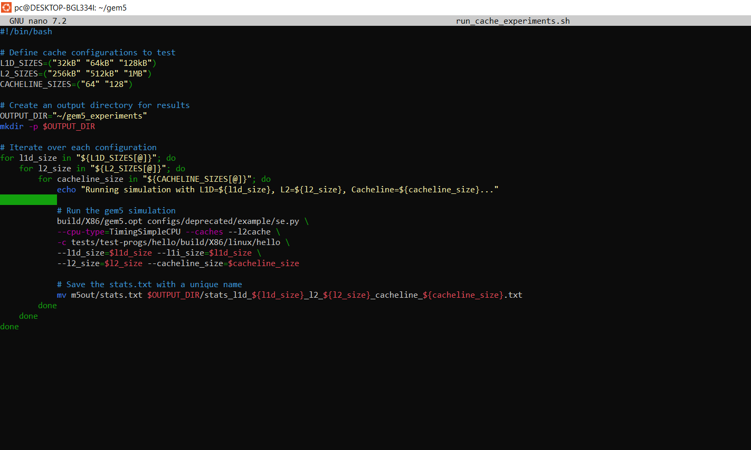



Key insights into performance trade-offs for alternative cache settings are revealed by the outcomes of varied cache configurations in the gem5 simulations. Important parameters including simulation time (simTicks), instructions per cycle (IPC), and cycles per instruction (CPI) were examined across all of the evaluated setups.

Modifying Cache Sizes: Typically, CPI and IPC were enhanced by increasing either the L1 data cache (l1d_size) or the L2 cache (l2_size). As an example, setups like L1D=32kB, L2=1MB, and Cacheline=128 show that a bigger L2 cache of 1MB lowered CPI from around 7.33 to 6.10. Because cache misses are less common at higher levels, this demonstrates improved memory access efficiency.

Influence of Cacheline Size: In comparison to 64-byte cachelines, configurations with 128-byte cachelines demonstrated improved simulation efficiency (simTicks and hostTickRate) and a small decrease in CPI. Overall speed is improved by using larger blocks, which assist reduce cache misses for sequential memory requests.

Balance between L1 and L2: Improving IPC by a little margin with a 64kB L1D cache size was most noticeable when combined with bigger L2 caches. It seems that the sizes of L1 and L2 work together to alleviate bottlenecks in memory-intensive tasks.

Observations on Performance: Memory performance was worse in configurations with smaller caches and cachelines, as seen by higher CPI values (e.g., 7.33 with 256kB L2 cache and 64B cacheline). On the other hand, CPI was reduced to 6.10 and IPC was increased to 0.1639 with ideal setups such as L1D=64kB, L2=1MB, and Cacheline=128.

Ultimately, these trials show how crucial it is to match cache settings with workload requirements for peak performance. While it's true that larger cache and block sizes often provide better outcomes, there may be a point of diminishing returns beyond which the benefits become less noticeable.